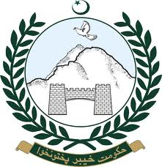  L&DD | 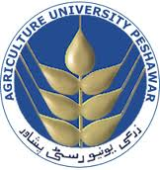  AUP | 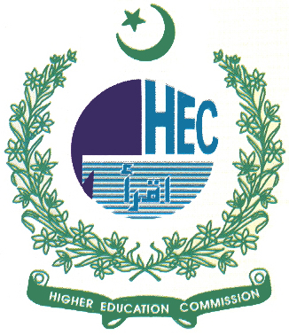  HEC |   PVMA  PVMA | Alltech

International Workshop on Dairy Science Park


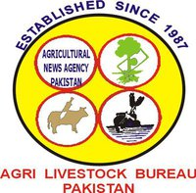





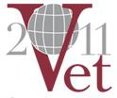

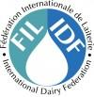


(November 21-23, IW-DSP-2011)
Venue: Khyber Pakhtunkhwa Agricultural University, Peshawar-25120, Pakistan
Workshop Update for Friday, July 31, 2026

The following committees are hereby constituted for upcoming Dairy Science Park Workshop.
- Finance committee:
- Prof. Dr. M. Subhan Qureshi, Dean FAHVS
- Dr. Farzand Ali Jan Director Finance AUP
- Dr. Sohail Akhter, Chairman LM
- Dr. Sohail Ahmed, Chairman ABG
- Dr. Sarzamin Khan, Chairman PS
- Dr. Nazir Ahmed, Chairman AN
- Dr. Umer Sadique, Chairman AH
- University Coordination Committee: Coordination with the University Administration and other Universities for extensive participation stalls management. The committee comprises the following members.
- Dr. Sohail Akhtar, Convener
- Dr. Syed Muhammad Sohail
- Dr. Abdul ur Rehman
- Dr. Younas Muhammad
- Dr. Sher Hayat Khan
This committee will comprise of the following sub committee.
- Stall Management Committee:
  - Dr. Muhammad Azeem Khan, Convener
  - Dr. Shoaib Sultan
  - Dr. Sher Bahadar
  - Dr. Tariq Hussain
  - Dr. Iftikhar Ahmed
  - Dr. Muhammad Aftab L&DD
  - Three Internees
- Accommodation, logistics and Security Committee: Management of conference halls, transport, reception and accommodation of guests and security. The committee comprises the following members.
- Dr. Nazir Ahmad, Convener
- Dr. M. Rafi, Provost
- Dr. Sher Hayat
- Dr. Noor Mula Khan
- Mr. Tahir Jr.
This committee will comprise of the following sub committee:
  - Transport Committee
- Dr Khalid Nawab, Convener
- Dr. Saleem Khan
- Dr. Zia ur Rehman
- Three Internees
  - Conference Halls Management Committee:
- Dr. Naila Imtiaz, Convener
- Dr. Ibadullah Jan
- Dr. Mushtaq Khattak
- Miss Naila Niaz
- Five Internees
- Business Coordination Committee: Business prospects and avenues in livestock farming; Coordination with co-organizers and business firms for generation of funds and development of incentive packages for farmers and graduates. This committee will comprise:
  - Dr. Farzand Ali Jan
  - Javed Khattak, Chief SMEDA
  - Maj.(Retd.)Tariq
  - Sheher Yar
  - Dr. Sarzamin Khan
  - Dr Iqbal Khattak
  - Dr Bakht Dararz
  - Dr Muhammad Ikhwan
  - Dr. Ihsanullah, Farm Manager
  - Dr. Wilayat Hussain
  - Mohsin Tooru
  - Geoff Kirton
  - Dr Sher Bahadar
  - Dr Murad Ali
  - Refreshment/Advertisement Subcommittee
- Dr Hamid Sattar
- Dr Zia ur Rahman
- Dr Sher Hayat
- Dr. Ihtisham ul Haq
- Development Coordination Committee: Coordination with leading farmers, provincial government departments including ministers, NGOs and development projects/business support agencies for inviting them to the workshop, getting success stories and development of a sustainable network. The committee comprises the following members.
- Dr. Sohail Ahmad, Convener
- Dr. Malik Ayaz
- Dr. Ihsanullah, Director, Animal Health
- Dr. Atta ullah
- Azam Shah
- Dr. Syed Zahid Ali Shah
- Dr. Shoakat, LTC
- Dr. Haq Amanullah

- Technical Coordination Committee: Contact with authors, preparation of scientific program for conference sessions, publication of brochures, proceedings, review of articles or publication in Pak Veterinary J and Sarhad J Agric, preparation of banners for the halls and other prominent locations. The committee comprises the following members. i. Dr. Umar Saddique, Convener
- Dr. Abdur Rehman
- Dr. Zahoor ul Hassan
- Dr Nazir Khan
- Dr. Mushtaq Khattak
- Dr. Ihsan Ali
- Dr. Farhan Anwar
- Dr. Sher Bahadar
This committee will comprise of the following publication sub-committee.
    - Prof Farhatullah, Convener
    - Dr. Tahir, AN
    - Dr. Zahoor ul Hassan
    - Dr. Mushtaq Khattak
    - Dr. Tariq Hussain
    - Dr. Ijaz
    - Mr. M. Azeem Khan
    - Dr. Shoaib
      - Poster & Advertisement Committee:
        - Dr. Sher Hayat Khan, Convener
        - Mr Gohar Rahman Khalil, IC CNEP
        - Mr Amin Khan, Webmaster
        - Dr. Zahir Shah
        - Dr. Obaidullah
        - Dr. Ijaz Ahmad
        - Dr. Zakir, LTC

